**SIMPLE PROGRAM IN A**

**RTIFICIAL NE**

**URAL NETWORK**

**AIM:**

To Create a simple

Artificial Neural Networ

k in Python.

**ALGORITHM:**

. Import the necessary libraries.

1

2

. Load and preprocess the data.

. Build the ANN model.

3

. Compile the model.

4

. Train the model.

5

. Evaluate the model.

6

**P**

**ROGRAM:**

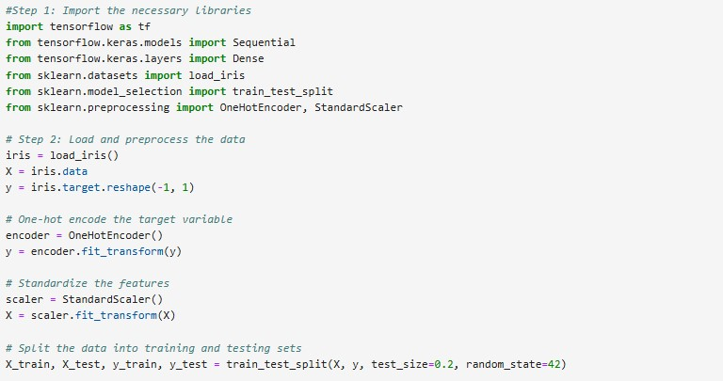

EX. NO : 11

DATE : 17/05/2024

220801140

**RESULT:**

This program is e

xecuted successfully.

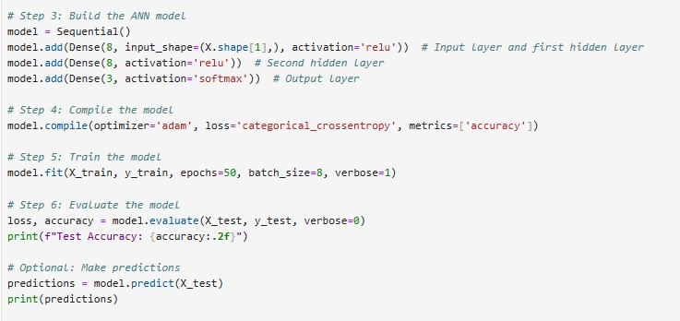

220801140